## **1.ReactJs-HOL:**

## **Objectives**

* Define SPA and its benefits
* Define React and identify its working
* Identify the differences between SPA and MPA
* Explain Pros & Cons of Single-Page Application
* Explain about React
* Define virtual DOM
* Explain Features of React

In this hands-on lab, you will learn how to:

* Set up a react environment
* Use create-react-app

## **Prerequisites**

The following is required to complete this hands-on lab:

* Node.js
* NPM
* Visual Studio Code

import Home from './Components/Home'

import About from './Components/About'

import Contact from './Components/Contact'

function App() {

  return (

   <div>

      <h1>Welcome to the first session of React</h1>

   </div>

  );

}

export default App;

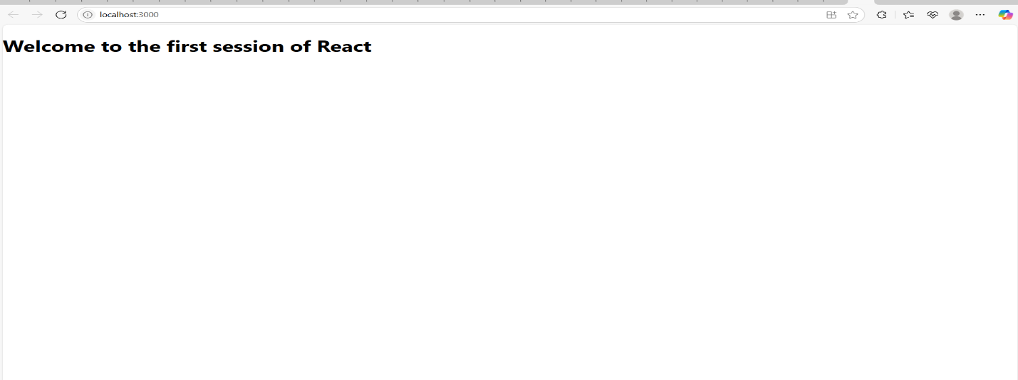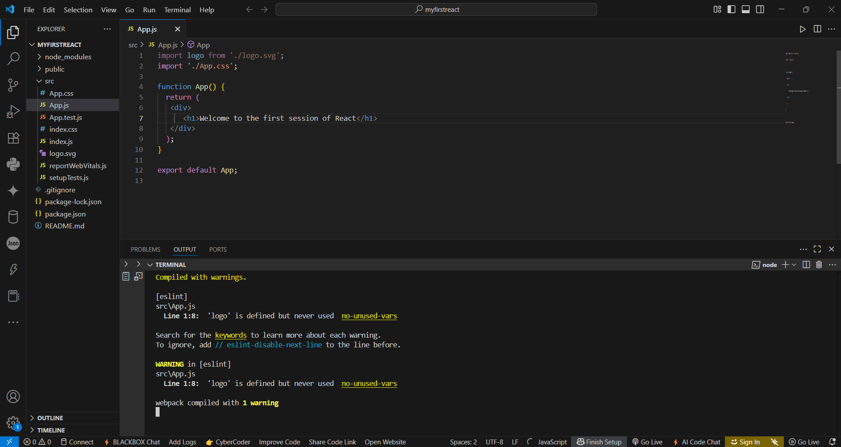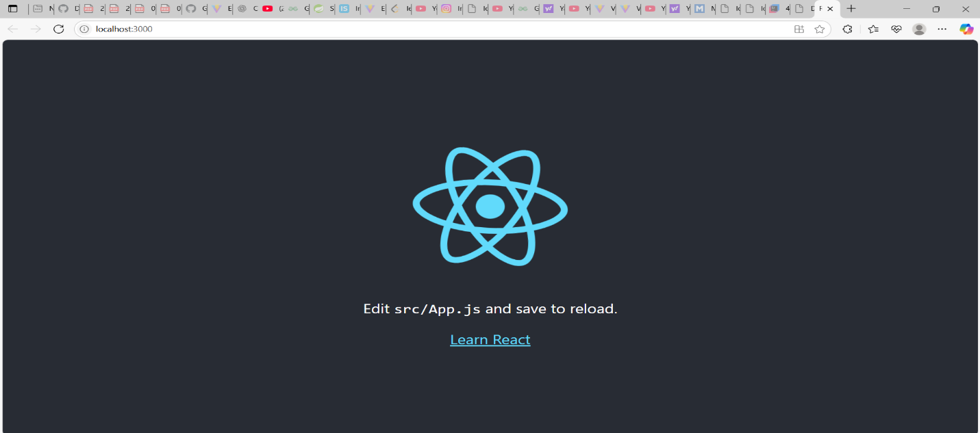

**2.ReactJs-HOL**

**Objectives**

* Explain React components
* Identify the differences between components and JavaScript functions
* Identify the types of components
* Explain class component
* Explain function component
* Define component constructor
* Define render() function

Create a react app for Student Management Portal named StudentApp and create a component named Home which will display the Message “Welcome to the Home page of Student Management Portal”. Create another component named About and display the Message “Welcome to the About page of the Student Management Portal”. Create a third component named Contact and display the Message “Welcome to the Contact page of the Student Management Portal”. Call all the three components.

1. Create a React project named “StudentApp” type the following command in terminal of Visual studio:
2. Create a new folder under Src folder with the name “Components”. Add a new file named “Home.js”
3. Type the following code in Home.js
4. Under Src folder add another file named “About.js”
5. Repeat the same steps for Creating “About” and “Contact” component by adding a new file as ”About.js”, “Contact.js” under “Src” folder and edit the code as mentioned for “Home” Component.
6. Edit the App.js to invoke the Home, About and Contact component as follows:
7. In command Prompt, navigate into StudentApp and execute the code by typing the following command:



1. Open browser and type “localhost:3000” in the address bar:

import logo from './logo.svg';

import './App.css';

import Home from './Components/Home'

import About from './Components/About'

import Contact from './Components/Contact'

function App() {

  return (

   <div className='container'>

      <h1>Welcome to the first session of React</h1>

      <Home/>

      <About/>

      <Contact/>

   </div>

  );

}

export default App;

import React from 'react'

const Home = () => {

  return (

    <div>

      <h1>Welcome to the Home Page of Student Management Potal</h1>

    </div>

  )

}

export default Home

import React from 'react'

const About = () => {

  return (

    <div>

      <h1>Welcome to the About Page of Student Management Potal</h1>

    </div>

  )

}

export default About

import React from 'react'

const Contact = () => {

  return (

    <div>

      <h1>Welcome to the About Page of Student Management Potal</h1>

    </div>

  )

}

export default Contact

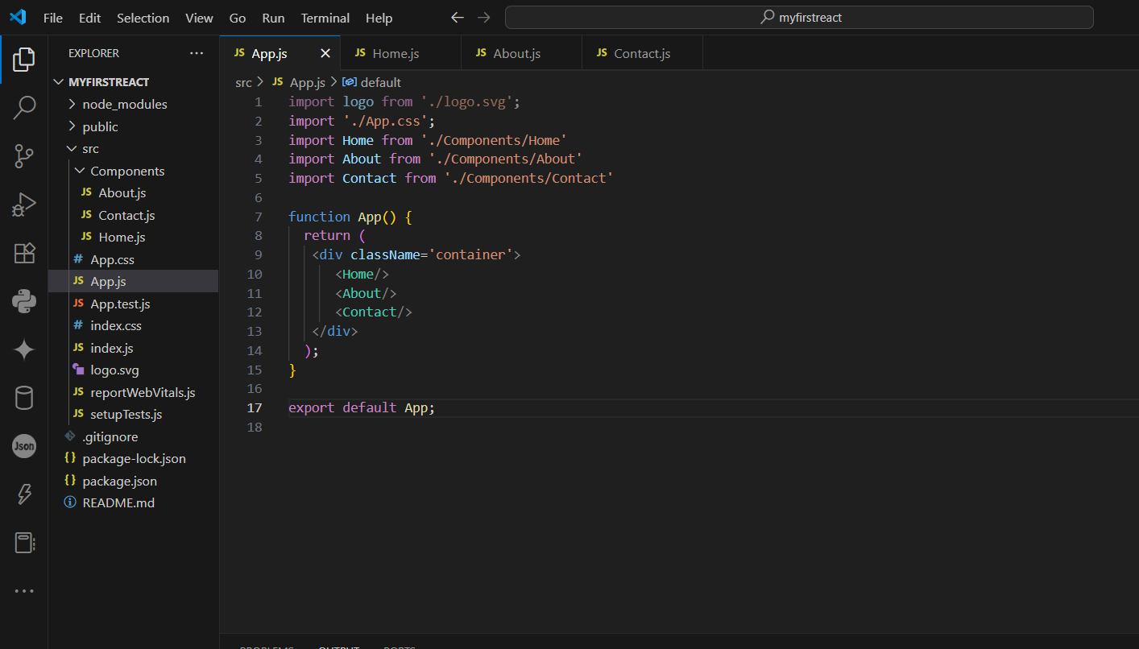

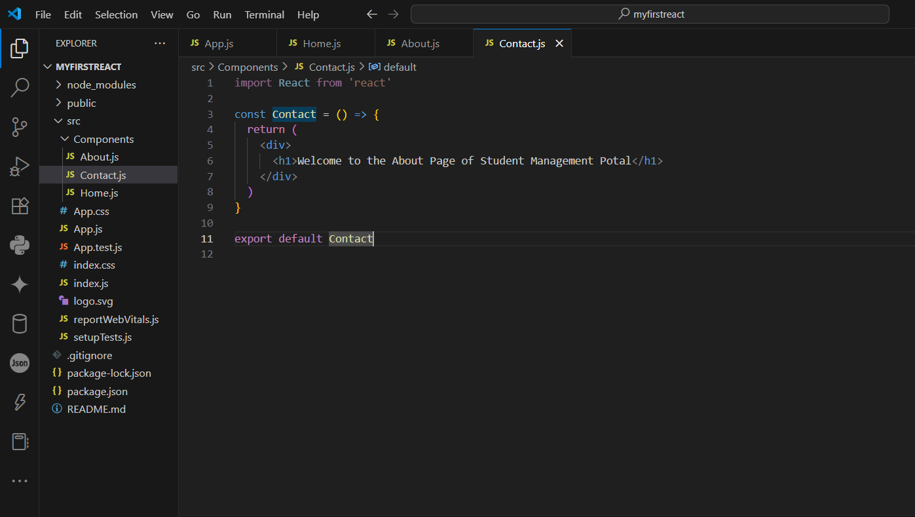

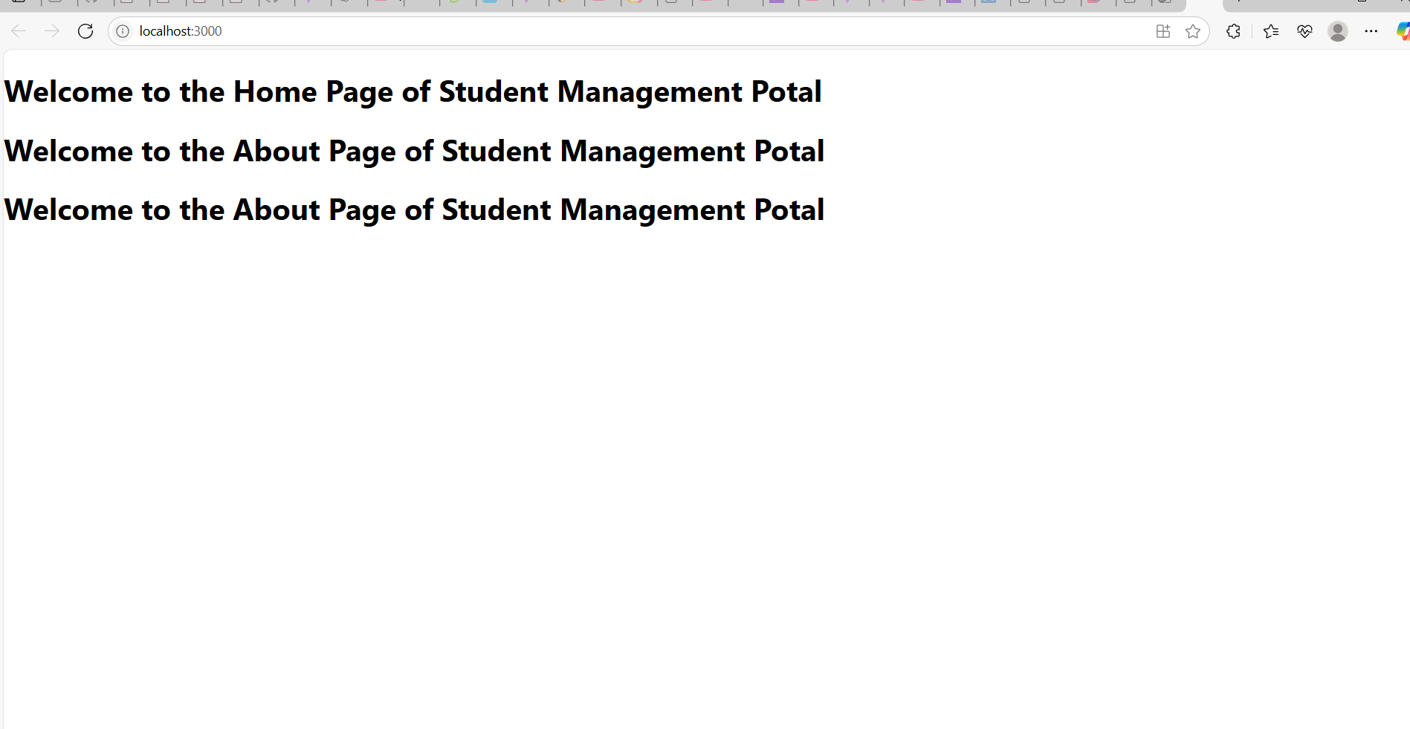

**3.ReactJs-HOL**

Objectives

* Explain React components
* Identify the differences between components and JavaScript functions
* Identify the types of components
* Explain class component
* Explain function component
* Define component constructor
* Define render() function

In this hands-on lab, you will learn how to:

* Create a function component
* Apply style to components
* Render a component

1.Create a React project named “scorecalculatorapp” type the following command in terminal of Visual studio:



1. Create a new folder under Src folder with the name “Components”. Add a new file named “CalculateScore.js”
2. Type the following code in CalculateScore.js
3. Create a Folder named Stylesheets and add a file named “mystyle.css” in order to add some styles to the components:
4. Edit the App.js to invoke the CalculateScore functional component as follows:
5. In command Prompt, navigate into scorecalculatorapp and execute the code by typing the following command:



1. Open browser and type “localhost:3000” in the address bar:
2. import './App.css';
3. import { CalculateScore } from './Components/CalculateScore';
4. function App() {
5. return (
6. <div>
7. <CalculateScore
8. Name="Steeve"
9. School="DNV Public School"
10. total={284}
11. goal={3}
12. />
13. </div>
14. );
15. }
16. export default App;

import '../Stylesheets/mystyle.css';

const percentToDecimal = (decimal) => {

  return (decimal.toFixed(2) + '%');

}

const calcScore = (total, goal) => {

  return percentToDecimal((total / goal) * 100);

}

export const CalculateScore = ({ Name, School, total, goal }) => {

  return (

    <div className="formatstyle">

      <h1 style={{ color: "brown" }}>Student Details:</h1>

      <div className="Name">

        <b><span>Name: </span></b>

        <span>{Name}</span>

      </div>

      <div className="School">

        <b><span>School: </span></b>

        <span>{School}</span>

      </div>

      <div className="Total">

        <b><span>Total: </span></b>

        <span>{total}</span>

        <span> Marks</span>

      </div>

      <div className="Score">

        <b>Score:</b>

        <span> {calcScore(total, goal)}</span>

      </div>

    </div>

  );

};

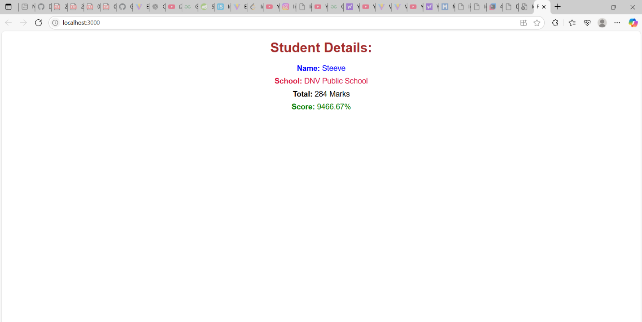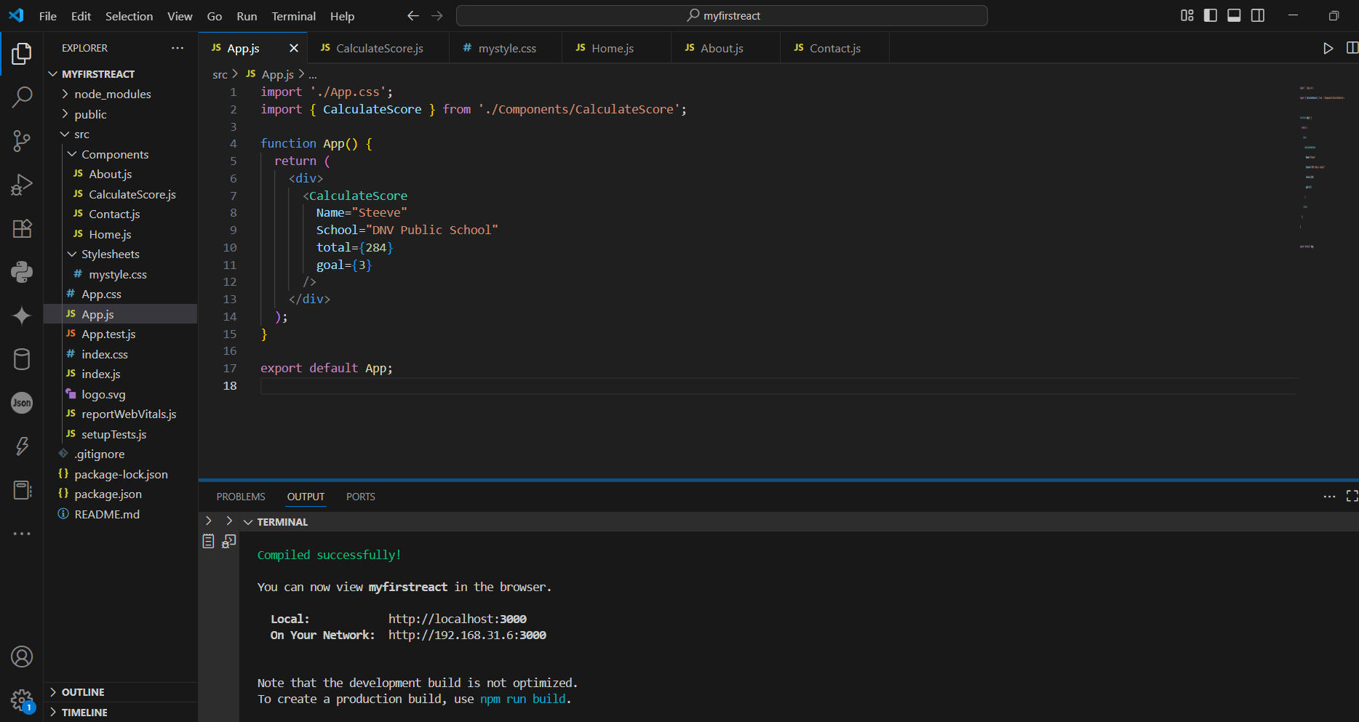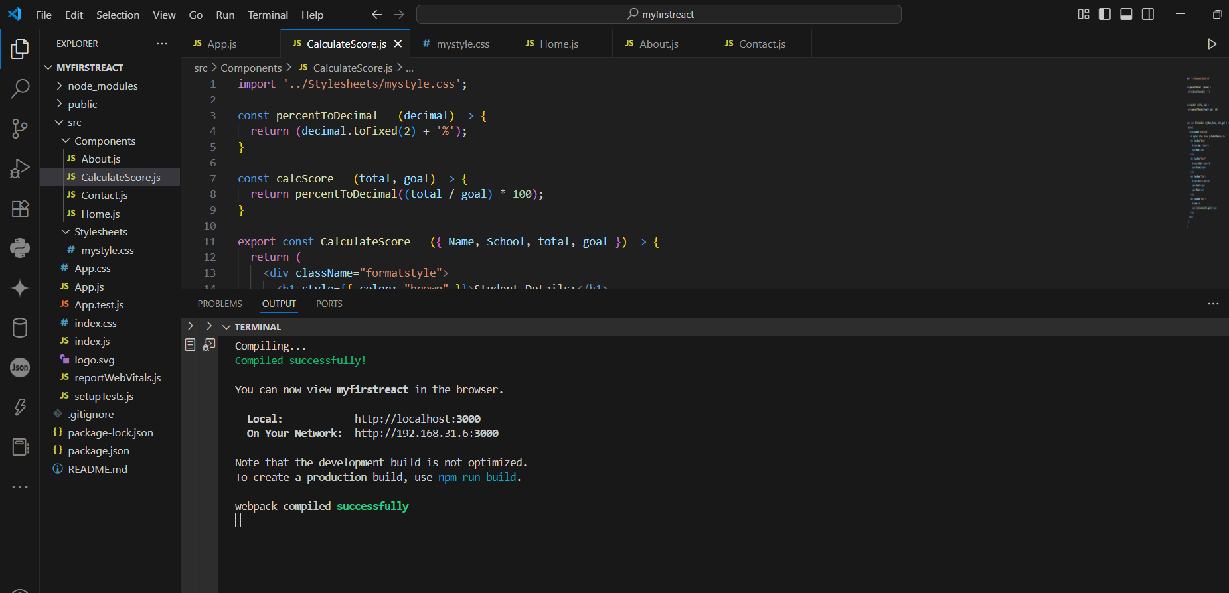

**4.ReactJs-HOL**

**Objectives**

* Explain the need and Benefits of component life cycle
* Identify various life cycle hook methods
* List the sequence of steps in rendering a component

In this hands-on lab, you will learn how to:

* Implement componentDidMount() hook
* Implementing componentDidCatch() life cycle hook.

**Prerequisites**

The following is required to complete this hands-on lab:

* Node.js
* NPM
* Visual Studio Code

**Notes**

1. Create a new react application using *create-react-app* tool with the name as “blogapp”
2. Open the application using VS Code
3. Create a new file named as **Post.js** in **src folder** with following properties

*Figure 2: Post class*

1. Create a new class based component named as **Posts** inside **Posts.js** file

*Figure 3: Posts Component*

1. Initialize the component with a list of Post in state of the component using the constructor
2. Create a new method in component with the name as **loadPosts()** which will be responsible for using Fetch API and assign it to the component state created earlier. To get the posts use the url (<https://jsonplaceholder.typicode.com/posts>)

*Figure 4: loadPosts() method*

1. Implement the **componentDidMount()** hook to make calls to **loadPosts()** which will fetch the posts

*Figure 5: componentDidMount() hook*

1. Implement the **render()** which will display the title and post of posts in html page using heading and paragraphs respectively.

*Figure 6: render() method*

1. Define a **componentDidCatch()** method which will be responsible for displaying any error happing in the component as alert messages.

*Figure 7: componentDidCatch() hook*

1. Add the Posts component to App component.
2. Build and Run the application using *npm start* command.

import React from 'react';

class Post extends React.Component {

  render() {

    const { title, body } = this.props;

    return (

      <div style={styles.card}>

        <h2 style={styles.title}>{title}</h2>

        <p style={styles.body}>{body}</p>

      </div>

    );

  }

}

// src/Posts.js

import React from 'react';

import Post from './Post';

class Posts extends React.Component {

  constructor(props) {

    super(props);

    this.state = {

      posts: [],

      hasError: false,

      errorMessage: ''

    };

  }

  loadPosts = () => {

    fetch('https://jsonplaceholder.typicode.com/posts')

      .then(response => {

        if (!response.ok) throw new Error("Failed to fetch");

        return response.json();

      })

      .then(data => {

        this.setState({ posts: data.slice(0, 5) }); // Limiting to 5 posts for brevity

      })

      .catch(error => {

        this.setState({ hasError: true, errorMessage: error.message });

      });

  };

  componentDidMount() {

    this.loadPosts();

  }

  componentDidCatch(error, info) {

    alert("An error occurred: " + error);

    console.error("Error caught:", error, info);

  }

  render() {

    if (this.state.hasError) {

      return <h3 style={{ color: 'red' }}>Something went wrong: {this.state.errorMessage}</h3>;

    }

    return (

      <div>

        <h1>Blog Posts</h1>

        {this.state.posts.map((post) => (

          <Post key={post.id} title={post.title} body={post.body} />

        ))}

      </div>

    );

  }

}

export default Posts;

import React from 'react';

import Posts from './Posts';

function App() {

  return (

    <div className="App">

      <Posts />

    </div>

  );

}

export default App;

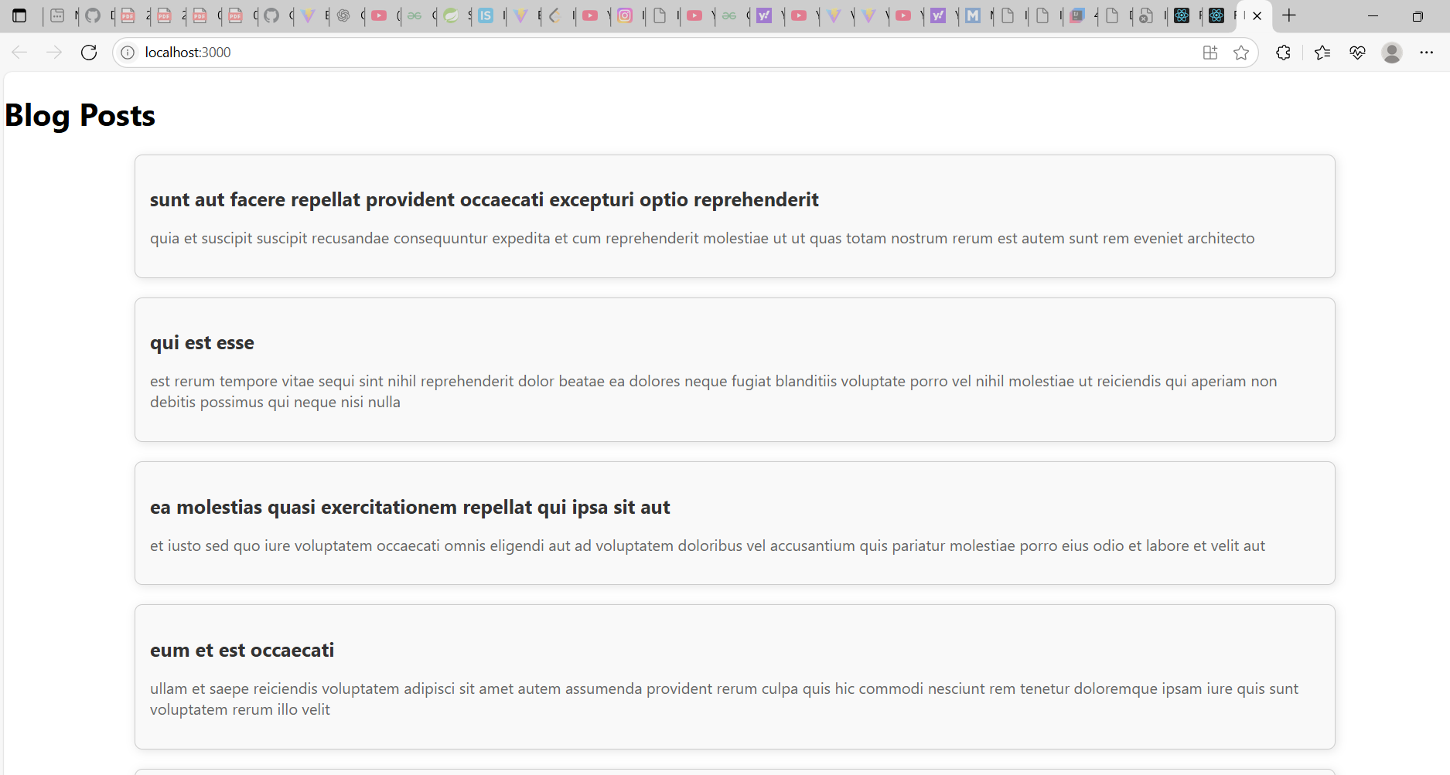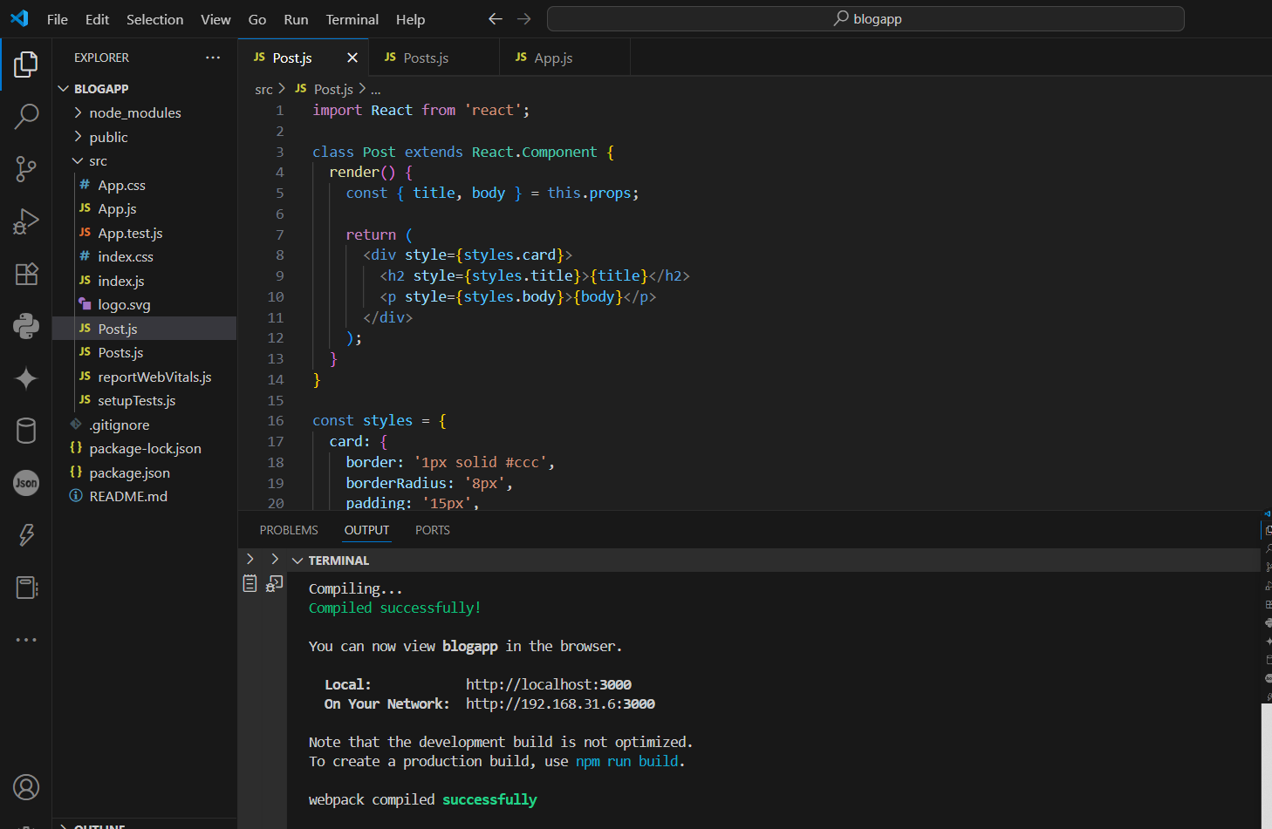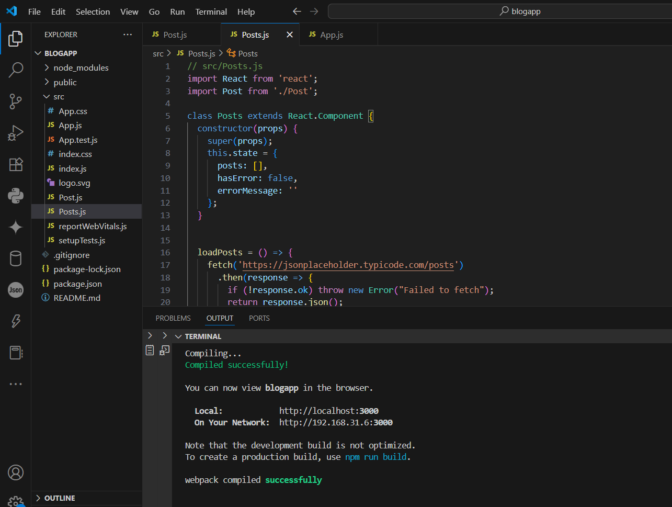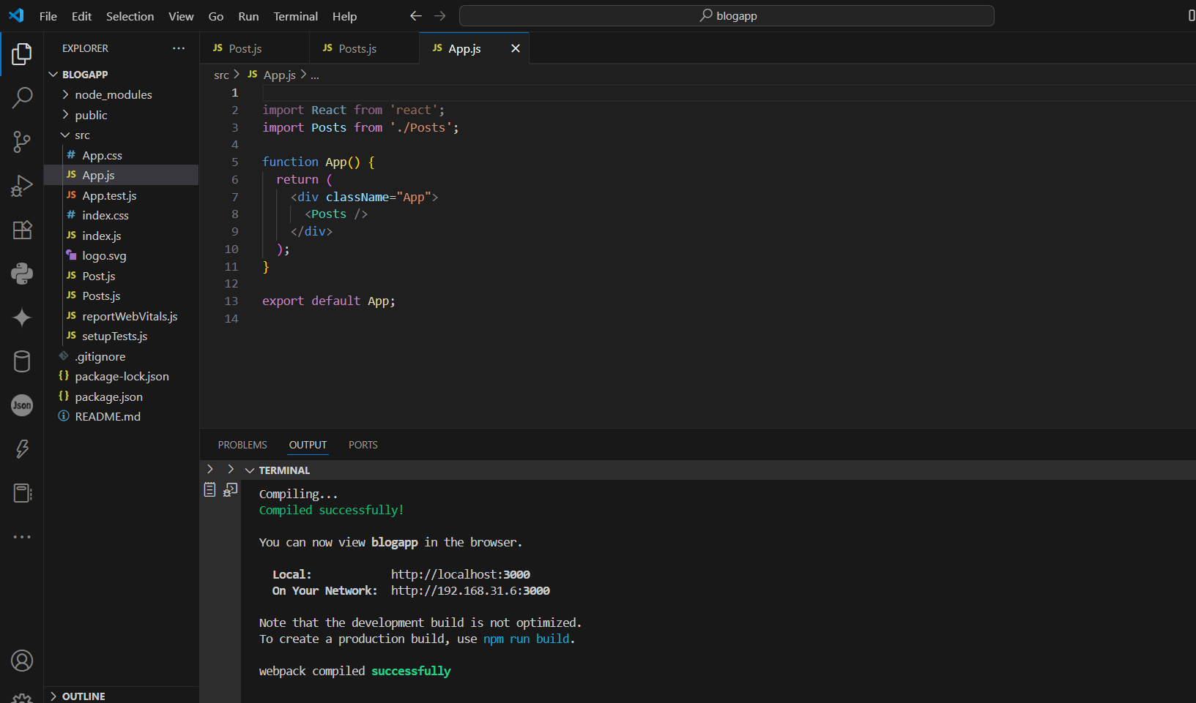

**5.ReactJs-HOL**

**Objectives**

* Understanding the need for styling react component
* Working with CSS Module and inline styles

In this hands-on lab, you will learn how to:

* Style a react component
* Define styles using the CSS Module
* Apply styles to components using className and style properties

**Prerequisites**

The following is required to complete this hands-on lab:

* Node.js
* NPM
* Visual Studio Code

**Notes**

Estimated time to complete this lab: **30 minutes.**

My Academy team at Cognizant want to create a dashboard containing the details of ongoing and completed cohorts. A react application is created which displays the detail of the cohorts using react component. You are assigned the task of styling these react components.

Download and build the attached react application.



1. Unzip the react application in a folder
2. Open command prompt and switch to the react application folder
3. Restore the node packages using the following commands

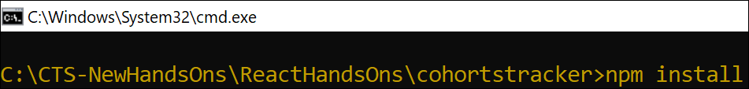

*Figure 1: Restore packages*

1. Open the application using VS Code
2. Create a new CSS Module in a file called “CohortDetails.module.css”
3. Define a css class with the name as “box” with following properties

*Width = 300px;*

*Display = inline block;*

*Overall 10px margin*

*Top and bottom padding as 10px*

*Left and right padding as 20px*

*1 px border in black color*

*A border radius of 10px*

1. Define a css style for html <dt> element using tag selector. Set the font weight to 500.
2. Open the cohort details component and import the CSS Module
3. Apply the box class to the container div
4. Define the style for <h3> element to use “green” color font when cohort status is “ongoing” and “blue” color in all other scenarios.
5. Final result should look similar to the below image

*Figure 2: Final Result*

import React from "react";

import styles from "./CohortDetails.module.css";

const CohortDetails = ({ cohort }) => {

  const titleStyle = {

    color: cohort.status === "ongoing" ? "green" : "blue",

  };

  return (

    <div className={styles.box}>

      <h3 style={titleStyle}>{cohort.name}</h3>

      <dl>

        <dt>Mentor:</dt>

        <dd>{cohort.mentor}</dd>

        <dt>Duration:</dt>

        <dd>{cohort.duration}</dd>

        <dt>Status:</dt>

        <dd>{cohort.status}</dd>

      </dl>

    </div>

  );

};

export default CohortDetails;

/* CohortDetails.module.css */

.box {

  width: 300px;

  display: inline-block;

  margin: 10px;

  padding: 10px 20px;

  border: 1px solid black;

  border-radius: 10px;

}

dt {

  font-weight: 500;

}

import React from "react";

import CohortDetails from "./Components/CohortDetails";

function App() {

  const cohorts = [

    { name: "React Bootcamp", mentor: "John", duration: "6 weeks", status: "ongoing" },

    { name: "Java Basics", mentor: "Lisa", duration: "4 weeks", status: "completed" },

  ];

  return (

    <div>

      {cohorts.map((cohort, index) => (

        <CohortDetails key={index} cohort={cohort} />

      ))}

    </div>

  );

}

export default App;

